EX No:1 | EDA-Data Cleaning
Aim:

Algorithm:

Program:
import os, glob, warnings
import numpy as np
import pandas as pd
import matplotlib.pyplot as plt
import seaborn as sns

warnings.filterwarnings("ignore")
sns.set_theme(style="whitegrid")
%matplotlib inline
# Path to the downloaded Kaggle CSV (place it in the same folder as this notebook)
DATA_PATH = "automobile_dataset.csv"

df_raw = pd.read_csv(DATA_PATH)
print("Shape:", df_raw.shape)
print("\nColumns:", df_raw.columns.tolist())
df_raw.head()
df_raw.info()
df_raw.describe(include='all').T
df_raw.isna().sum().sort_values(ascending=False).head(20)
# Quick look at categorical vs numeric columns
num_cols = df_raw.select_dtypes(include=np.number).columns.tolist()
cat_cols = df_raw.select_dtypes(exclude=np.number).columns.tolist()
print("Numeric columns:", num_cols)
print("Categorical columns:", cat_cols)

Output:
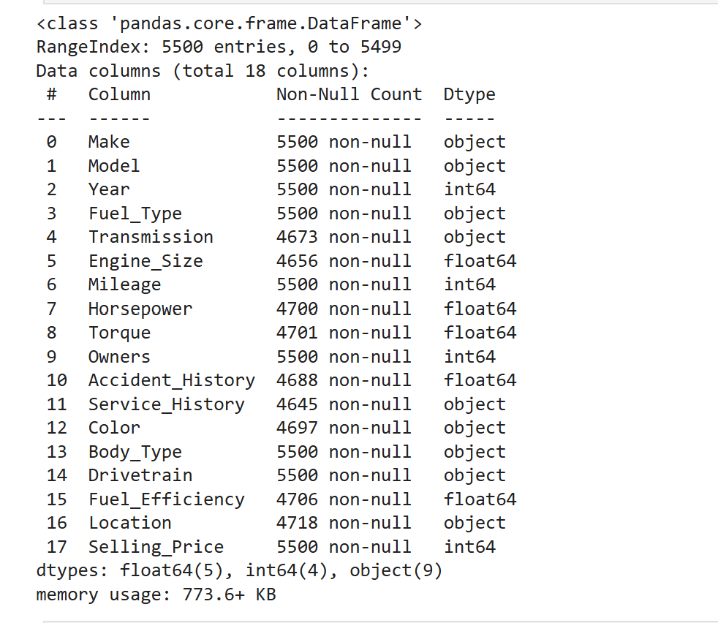
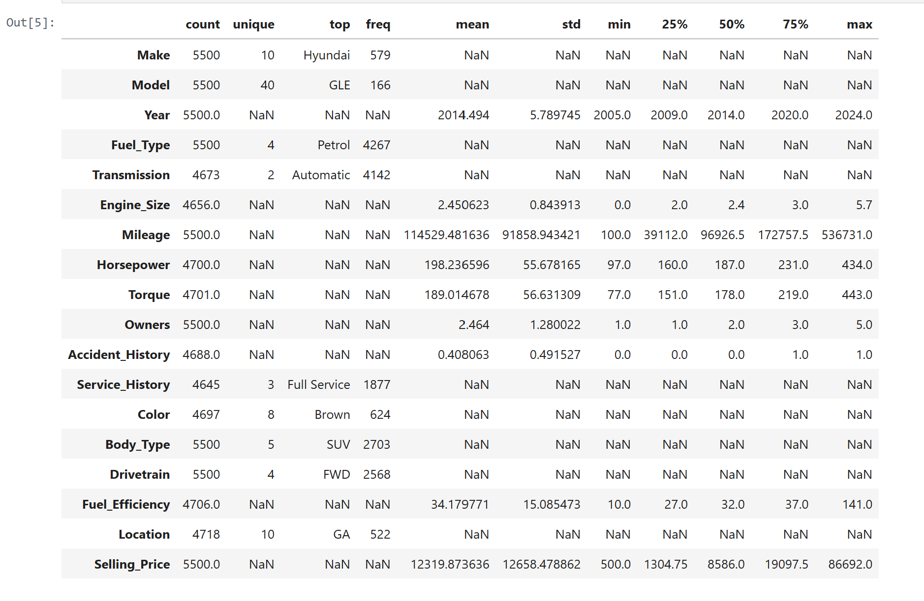
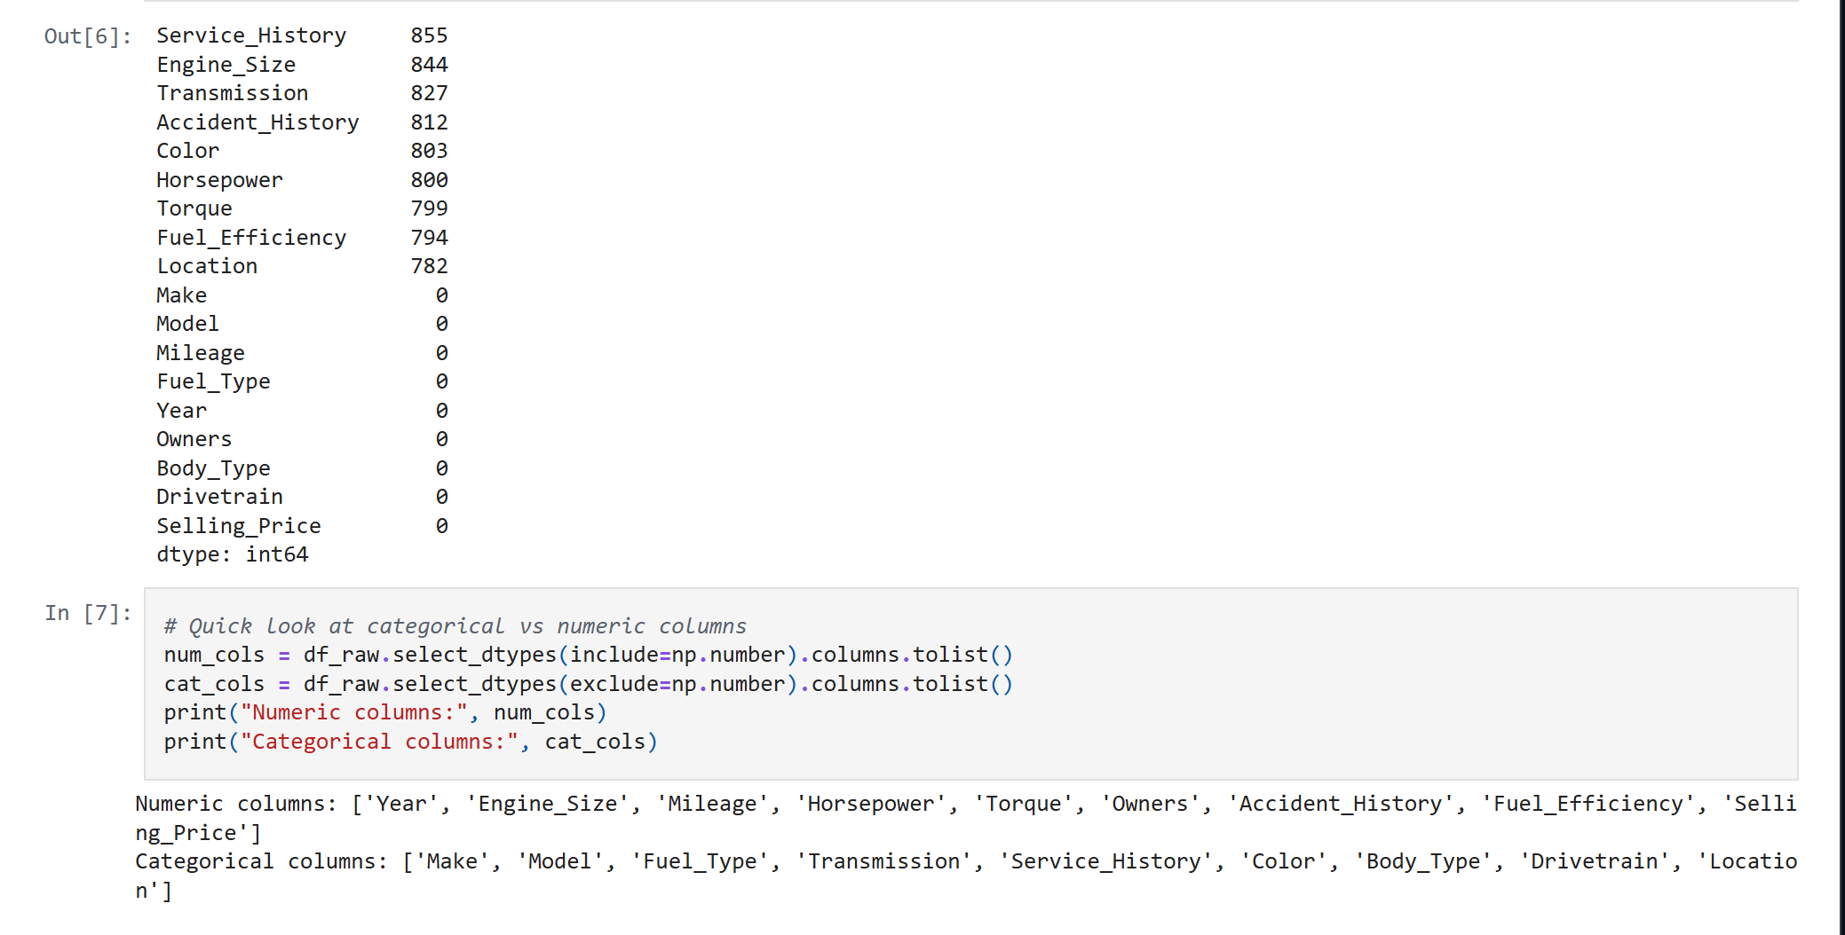

Result:

